June 6, 2018

Dear Neighbor,

You are invited to join us as we share information about planned work in your community.

As part of our everyday effort to deliver secure and reliable energy to our customers and community, Eversource received approval from the Energy Facilities Siting Board (EFSB) to install two new 115-kV underground transmission lines in your area.

The project, called the Mystic to East Eagle to Chelsea Project (“Project”), is approximately 5 miles and will run through portions of Chelsea, East Boston and Everett, Massachusetts.

This project will improve the transmission system in the Greater Boston area so customers will continue to have reliable electric power to meet their growing energy needs. It will also ensure that the area’s electric grid conforms to national and regional reliability standards.

Since a portion of the project route is located near your property, we are committed to keeping you updated as the project advances toward construction. In support of that effort, Eversource will be holding an Information Session to provide you with information and an opportunity meet with members of the project team and ask questions about the project.

The Information Session for the Mystic – East Eagle - Chelsea project will be held:

Thursday, June 14, 2018
Drop in between 6 p.m. - 8 p.m.

Chelsea City Hall
500 Broadway Street, Room 305
Chelsea, MA 02150

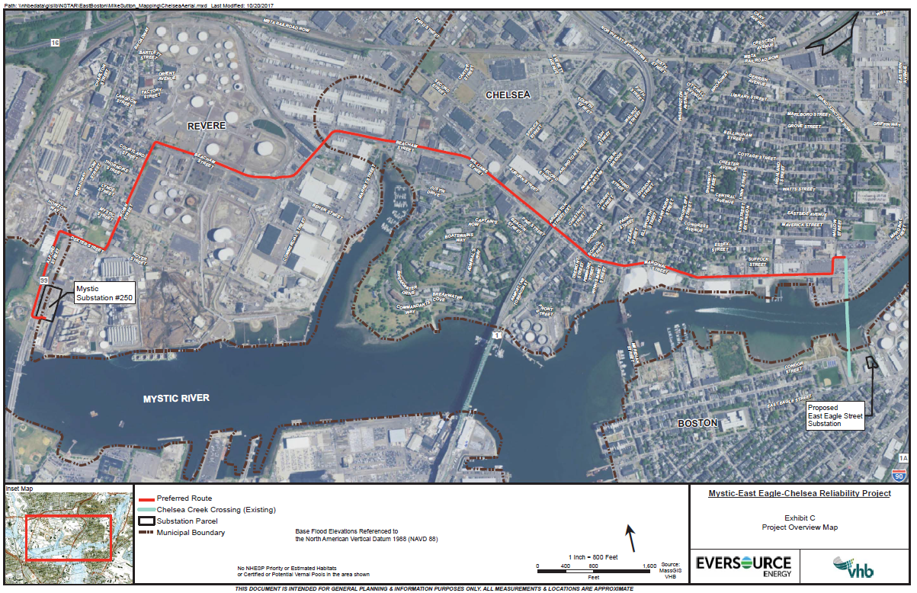
Keeping the lines of communication open is an important part of our work in your community. We hope you can join us for the upcoming Information Session. If you have questions about the proposed project, please visit the Eversource website, call the Eversource Transmission Information Line at 1-800-793-2202, or send an email to TransmissionInfo@eversource.com.

